

**College Library Management System**

**Software Requirement Specification (SRS) Document**

**Sprint 1 Implementation**

**Project Timeline: 20.10.2022 to 27.10.2022**

**INDEX**

1. Introduction

1.1 Purpose ------------------------------- 4

1.2 Intended audience ------------------------------- 4

1.3 Intended use ------------------------------- 4

1.4 Scope ------------------------------- 4

2. Overall description ------------------------------- 5

2.1 Assumptions and dependency ------------------------------- 5

3. System feature and requirements ------------------------------- 5

3.1 Functionality ------------------------------- 5

3.1.1 CLMS_01->Librarian Registration ------------------------------ 5

3.1.2 CLMS_02-> Add Student ------------------------------ 5

3.1.3 CLMS_03->Add Books ------------------------------ 5

3.1.4 CLMS_04-> Search Books ------------------------------ 5

3.1.5 CLMS_05->Delete Books ------------------------------ 6

3.1.9 CLMS_06-> Display the Books ------------------------------ 6

3.1.10 CLMS_07-> Issuing the Book ----------------------------- 6

3.1.11 CLMS_08-> Update the record ----------------------------- 6

3.1.12 CLMS_09-> Returning the Book ------------------------------ 6

3.1.13 CLMS_10-> Maintain the track of books and students ------------------------ 6

3.2 System requirement ------------------------------ 6

3.2.1 Tools to be used ------------------------------ 6

3.3 System feature ------------------------------ 6

4. Data Flow Diagram

4.1 DFD level 0 ------------------------------- 7

4.2 DFD level 1 ------------------------------- 7

### 

### **Introduction: -**

### The introduction of the software requirement specification provides an overview of the entire software. The entire SRS with overview description purpose, scope, tools used and basic description. The aim of this document is to gather, analyze and give an in-depth insight into the complete College Library Management System by defining the problem statement in detail. The detailed requirement of the College Library Management System is provided in this document.

* 1. **Purpose**: **-**

The purpose of College Library Management System is to manage and store the books information electronically according to student needs. The system helps both students and librarian to keep a track of all books available in library. It allows both the librarian and students to search for the desired book.

**1.2** **Intended Audience: -**

There is no such specific audience, it could be a librarian or student also..

**1.3** **Intended Use: -**

* Development Team
* Maintenance Team
* Clients

Since this a general-Purpose Software any one can access it.

**1.4** **Scope: -**

It provides general architecture for College Library Management System, This system consists of track of all the books in the library with the librarian and allows the students to borrow the books from the library. This is written C Linux Language..

The application is divided into two parts, librarian and student, the librarian in this project will add, search and delete the books from the library. Students are used to borrow the books from the library and return back to the library by using credentials. Librarian is allowed to add the books by using the credentials.

**2. Overall Description: -**

The College Library Management System is a system which provides the required books for the students. This system consists of the database which holds the details of the books like Book ID, Book Name, Author Name.

The librarian can update the books in the library records. The student has to search for the book that he or she wanted then borrow the book from the library. If a student borrow the book from library, the librarian has to update the record of the books in the library.

The main purpose of this application is to provide the students all kinds of books from the library. The student also has to return the book to the library after the usage of books.

**2.1 Assumptions and Dependency: -**

* System should have any flavor of Linux installed.
* System should have either 4GB or more RAM.
* The service is used preferably on a desktop or laptop.

**3. System Features and Requirements: -**

**3.1 Functionality: -**

**3.1.1 CLMS_01->Librarian Registration :** Librarian who are willing to add the books need to register using their personal details which includes the Username and Password.

**3.1.2 CLMS_02-> Add Student**: Librarian is supposed to add the student in the system by taking some of the details from the student like Student ID, Student Name, Course Name.

**3.1.3 CLMS_03->Add Books**: The Librarian who has logged in successfully can add the books to the library records. The Librarian is only having the access to add the books into the records.

**3.1.4 CLMS_04->Search Books:**  After adding the books successfully, the Librarian can search for the specific book from the library records.

**3.1.5 CLMS_05->Delete Books:** The Librarian is given access to delete the books from library records. The student cannot delete the books from the records even after successful registration.

**3.1.9 CLMS_06-> Display Books:**  The librarian is given access to display the track of records present in the library.

**3.1.10 CLMS_07-> Issuing the Book:** On providing all the details of student to the librarian, the students are allowed to issue the book from the library.

**3.1.11 CLMS_08-> Update the Record:**  This function provides access for the librarian to update the library record after issuing the book to the students.

**3.1.12 CLMS_09-> Returning the Book:**  The students have to return the issued book by providing valid details of them to the librarian.

**3.1.13 CLMS_10->Maintain the track of books and students:** This function gives access to the librarian to maintain all the records of the books and students.

**3.2 System Requirements: -**

### **3.2.1. Tools to be used:**

* Valgrind
* Splint
* Makefile
* C File Handling

### **3.3 System Features: -**

### Supportability:The system is easy to use.

* Design Constraints: The system is built using only C language.
* Usability:The College Library Management System can be used add, search, delete, borrow and return the books.
* Reliability & Availability**:** The system is available 24/7 that is whenever the user would like to use the system, they can use it up to its functionalities.

### Performance: The system will work on the user’s terminal**.**

**4. Data Flow Diagram:**

**4.1 DFD Level 0 –**

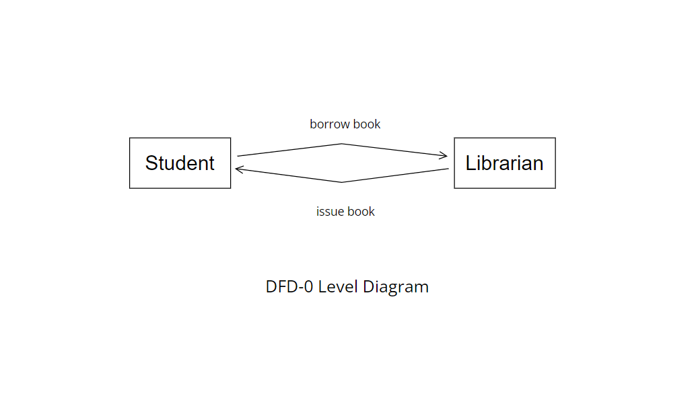

**4.1 DFD Level 1 –**

